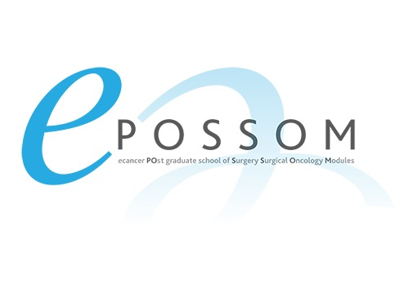
Application to participate in EPOSSOM
eCancer and Severn Deanery collaboration
Online Learning Modules
Name
Contact Phone Number
Contact Email
Current CT/ST year and declaration of speciality if any | CT year  ST year
Previous Medical Educational Activity, eg Certificate in MedEd or education projects

Have you done a Cochrane review?
Other projects completed in past eg research and others activity
Why do you want to be involved specifically in this project?  Preference of module subject | Breast or Colorectal or No preference (delete as needed)

Please also send an up to date CV to confirm activity, and skills, to Chad.Elliott@southwest.hee.nhs.uk

